**System Architecture:**

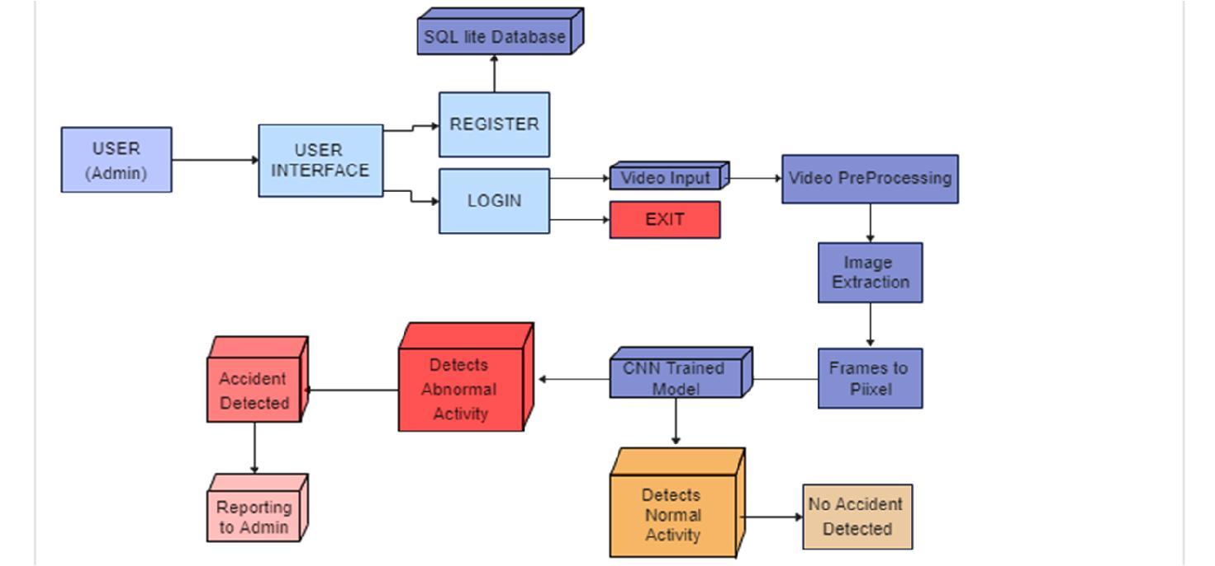

* **Register:** A user first registers themselves in the system. This could be an admin or a regular user.
* **User Login:** The user then logs in to the system.
* **User Interface:** This is the interface that the user interacts with to use the system. It likely provides options to upload videos and view results.
* **Video Input:** This block represents the video that is uploaded to the system for processing.
* **Video Preprocessing:** This block performs preprocessing steps on the video, such as resizing or converting the format.
* **Image Extraction:** Here, individual images, or frames, are extracted from the video.
* **CNN Trained Model:** A convolutional neural network (CNN) is a type of artificial neural network that is particularly well-suited for image recognition and classification tasks. In this system, a pre-trained CNN model is used to analyze the extracted images from the video to detect accidents.
* **Accident Detected:** If the CNN model detects an accident in the video, the system moves on to the reporting stage.
* **Normal Activity Detected:** If the CNN model does not detect an accident, then the system recognizes this as normal activity.
* **Reporting to Admin:** If an accident is detected, the system generates a report and sends it to the admin.

SQL Lite Database: This block likely refers to a database that the system uses to store information, such as user login information or the results of video processing.